**CENWP-ODJ11/30/2023**

**MEMORANDUM FOR THE RECORD**

**SUBJECT: *23JDA41 MU-13 VBS Failure***

On 29 November 2023, at approximately 1500, JDA-F personnel performed an ROV inspection in main unit 13 (MU-13). Personnel were inspecting the vertical barrier screens (VBS) for any missing fasteners. Several fasteners from MU-13 gatewells A&B were missing and the screen was pulling away from the wall. As a result, unit-13 was taken out of service, and repairs are underway.

On 30 November, JDA Maintenance “*crew got the STS out of MU-13 and the bulkhead installed today. During that process the VBS got shoved back more vertical and should be ok until morning. The danger of it falling out on to the STS has been resolved… MU-03 they are removing the STS now and that will give us a jump start tomorrow. But things are going good at the moment. I just wanted to bring everyone up to speed before the weekend starts.*” Terry Maine PP Mechanical Crew Supervisor

Future and Preventative Measures- All VBSs are being inspected by ROV. Fisheries personnel intend to make this an annual inspection as units must be off and orifices must be closed to complete.

Sincerely,

JDA Project Fisheries

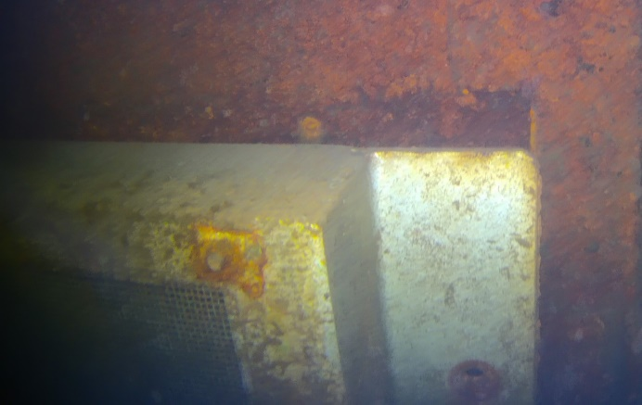 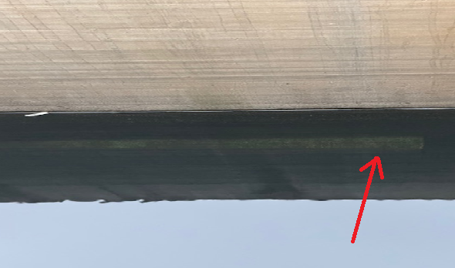

Figure 1: ROV picture from MU-13 Fig 2: VBS from intake deck looking down.